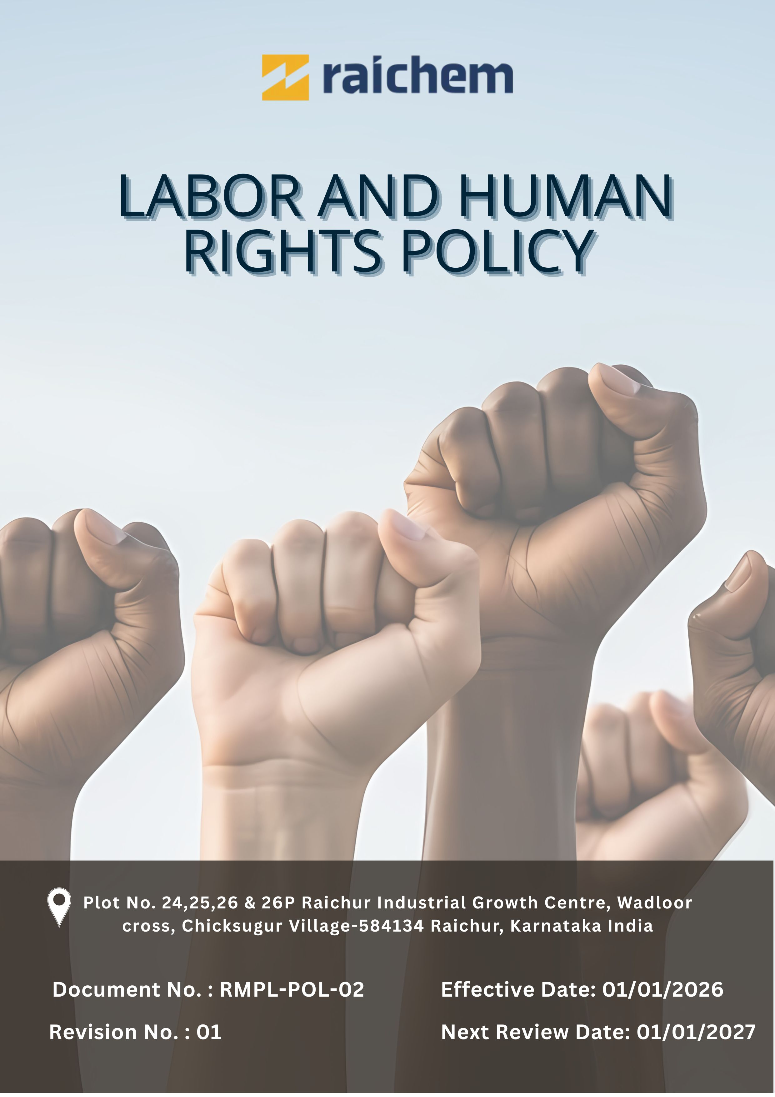

Contents

Preface 3
Policy Declaration 3
Scope 3
Key Focus Areas 4
Qualitative Objectives 4
Quantitative Targets 6
Alignment with the United Nations Sustainable Development Goals (SDGs) 9
Responsibilities 9
Monitoring, Reporting, and Transparency 9
Review Mechanism and Continuous Improvement 10
Employee Acknowledgment Form 11

LABOUR AND HUMAN RIGHTS POLICY

Preface
Raichem Medicare Pvt. Ltd. recognises that respect for human rights and fair labour practices are essential to ethical business conduct and long-term sustainability. The Company is committed to ensuring that all individuals working for or on its behalf are treated with dignity, fairness, and respect, and that their rights are safeguarded across all operations.
This Labour and Human Rights Policy outlines Raichem’s principles and expectations relating to lawful employment, equal opportunity, safe and healthy working conditions, and responsible labour practices. The policy is aligned with applicable labour laws and internationally recognised human rights standards and provides a framework for fostering an inclusive workplace that supports employee well-being, accountability, and responsible business growth.

Policy Declaration
Raichem Medicare Pvt. Ltd. is committed to upholding fundamental human and labour rights across its operations by ensuring fair wages, safe and healthy working conditions, equal opportunity, and full compliance with applicable labour laws. The Company strictly prohibits child labour, forced labour, discrimination, harassment, and unethical employment practices, and expects its employees, suppliers, and business partners to uphold these principles in line with responsible and ethical business conduct.

Scope
This policy applies to all employees, contractors, suppliers, business partners, and service providers engaged with Raichem across its operations. It governs all aspects of the employment relationship, including recruitment practices, wages and benefits, working hours, career development, workplace conditions, occupational health and safety, and overall employee well-being. All covered parties are required to comply with labour and human rights standards in alignment with the Company’s commitment to ethical, fair, and responsible business conduct.

Site | Address
Raichem Medicare Pvt. Ltd. | Plot No. 24,25,26 & 26P Raichur Industrial Growth Centre, Wadloor cross, Chicksugur Village 584134 Raichur, Karnataka, India

Key Focus Areas
- Employees’ Health and Safety – Maintain a safe and healthy workplace through risk control and regular training.
- Working Conditions – Provide respectful, clean, and ergonomically safe work environments.
- Social Dialogue – Promote open communication, employee engagement, and effective grievance mechanisms.
- Career Management and Training – Support continuous learning and career development through structured training.
- Child Labor, Forced Labor, and Human Trafficking – Prohibit all forms of child labour, forced labour, and human trafficking across operations and the supply chain.
- Non-Discrimination and Harassment – Prevent discrimination and harassment and ensure safe, confidential reporting without retaliation.
- External Stakeholder Human Rights – Require suppliers and partners to uphold human rights and ethical labour standards.
- Fair Wages & Benefits – Ensure lawful, timely, and fair compensation in line with statutory and industry standards.
- Work-Life Balance – Encourage healthy work-life balance through flexible practices and wellness programs.

Qualitative Objectives
- Employee Health and Safety
- Foster a strong safety culture guided by ISO 45001 standards and proactive risk prevention across all plant operations.
- Ensure continuous training on safe practices, hazard identification, and emergency preparedness for all employees and contractors.
- Strengthen monitoring and reporting of health and safety performance to reduce incidents and improve workplace well-being.

- Working Conditions
- Ensure all workplaces meet statutory requirements related to cleanliness, ventilation, lighting, and welfare facilities.
- Promote respectful supervision and ethical management practices at all levels of the organization.

- Social Dialogue
- Encourage open and transparent communication through structured internal channels.
- Hold periodic labour–management interactions with documented discussions and follow-up actions.
- Support employee representation and participation in workplace matters in line with applicable laws.

- Career Management and Training
- Encourage career progression and continuous growth aligned with company and individual goals.
- Support employee development through structured learning opportunities and performance feedback.

- Child Labor, Forced Labor, and Human Trafficking
- Uphold zero tolerance for child labor, forced labor, discrimination, and unfair employment practices across operations.
- Uphold dignity, fairness, and equal treatment for all employees and contract workers.
- Conduct due diligence on suppliers and business partners regarding labor practices.

- Non-Discrimination and Harassment
- Maintain a respectful, inclusive, and professional workplace with zero tolerance for discrimination, harassment, or abusive behavior.
- Strengthen and continuously improve grievance redressal mechanisms to ensure fair, timely, and transparent resolution of concerns.

- External Stakeholder Human Rights
- Promote respect, dignity, and fair treatment across supply chain by embedding internationally recognized human rights principles in supplier engagement.
- Strengthen ethical partnerships with suppliers and stakeholders by requiring compliance with labour laws, human rights expectations, and responsible business practices.

- Fair Wages & Benefits
- Ensure wages, benefits, and statutory contributions meet or exceed applicable legal and industry requirements.
- Promote transparent wage structures and timely payment of salaries and benefits.
- Periodically review compensation practices to ensure fairness, consistency, and compliance.

- Work-Life Balance
- Encourage a positive work culture that help employees balance professional and personal needs.
- Support employee wellness through flexible practices and well-being initiatives.

Quantitative Targets
All targets defined under the Labour and Human Rights Policy use FY 2022–23 as the baseline year for measurement. Progress is reviewed on an annual basis, with the objective of achieving the established targets by FY 2029–30. This includes strengthening employee well-being, ensuring ethical labour practices, promoting diversity and inclusion, maintaining fair wages and benefits, and fostering responsible engagement with business partners and other stakeholders.

- Employee Health and Safety
- Ensure 100% of employees always have access to health and safety policies, emergency procedures, and safety instructions.
- Increase planned safety inspections by 5% by FY 2029–30 to proactively identify and mitigate workplace risks.
- Maintain a zero-fatality objective across all operational sites.

- Working Conditions
- Achieve 95% positive employee satisfaction scores in annual working-condition surveys by FY 2029–30.
- Provide statutory healthcare and insurance benefits to 100% of eligible employees by FY 2029–30.

- Social Dialogue
- Achieve 100% participation in employee engagement or feedback activities by FY 2029–30.
- Ensure 100% of employees have access to formal grievance redressal and feedback mechanisms.
- Conduct 4 structured employee engagement initiatives by FY 2029–30.

- Career Management and Training
- Conduct annual performance reviews and maintain documented development plans for 100% of eligible employees.
- Allocate 10% of HR budget towards training, skill development, and upskilling initiatives till FY 2029–30.
- Increase internal promotions by 10% by FY 2029–30 through structured career pathways and targeted development programs.

- Child Labor, Forced Labor, and Human Trafficking
- Conduct labour compliance assessments for 100% of key suppliers and contractors by FY 2029–30.
- Ensure 100% employee completion of annual human rights and ethics training.
- Maintain 0 confirmed cases of child labor, forced labor, or human trafficking across raichem operations annually.

- Discrimination and Harassment
- Conduct 2 workplace climate surveys on discrimination and harassment till FY 2029-30 through survey forms filled by 100% employees.
- Maintain zero confirmed cases of discrimination or harassment.
- Provide mandatory anti-harassment, POSH training to 100% employees annually.

- External Stakeholder Human Rights
- Ensure 50% of key suppliers to undergo human rights due-diligence assessments by FY 2029-30.
- Ensure that 100% of supplier contracts include and comply with human rights clauses by FY 2029–30.

- Fair Wages and Benefits
- Provide statutory and company-sponsored benefits (including insurance, social security, and retirement benefits) to 100% eligible employees.
- Ensure 100% compliance with all applicable minimum wage, wage payment, and statutory benefit requirements across locations, with zero instances of wage-related non-compliance.

- Work-Life Balance
- Ensure 100% compliance with statutory working hours, overtime limits, and leave entitlements.
- Offer flexible work arrangements for 100% eligible employees, subject to role feasibility.

Alignment with the United Nations Sustainable Development Goals (SDGs)
The sustainability objectives and performance targets align with the following Sustainable Development Goals (SDGs):
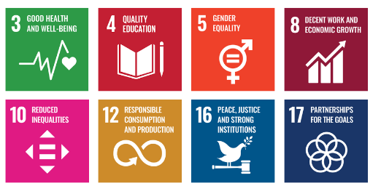

Responsibilities
- Board & Senior Management: Set direction, ensure legal compliance, and embed human rights into governance and strategy.
- Managing Director & Executive Team: Lead policy implementation, monitor risks, and ensure corrective actions are taken.
- HR: Ensure fair recruitment and employment, manage DE&I and anti-harassment practices, maintain records, provide training, and manage confidential reporting.
- Department Heads & Supervisors: Apply human rights principles in daily operations, identify risks, and support fair treatment and grievance resolution.
- Employees: Follow the policy, participate in training, and report concerns responsibly.
- Supply Chain & External Partners: Comply with supplier human rights standards and cooperate with audits and improvements.

Monitoring, Reporting, and Transparency
Raichem Medicare Pvt. Ltd. undertakes continuous monitoring of its labour standards and human rights performance across key areas, including employee health and safety, working conditions, social dialogue, learning and career development, prevention of child and forced labour, non-discrimination and harassment, and the protection of external stakeholder human rights. Defined Key Performance Indicators (KPIs) are tracked through established internal monitoring mechanisms, with performance reviewed quarterly and consolidated reporting provided to senior management to support informed and responsible decision-making. Annual assessments are conducted to evaluate overall progress, identify gaps and improvement opportunities, and implement corrective actions where required. Relevant information is communicated to appropriate stakeholders to enhance transparency and accountability. All monitoring and reporting processes are aligned with applicable labour laws, internationally recognised human rights principles, and industry best practices to ensure accuracy, consistency, and credibility.

Review Mechanism and Continuous Improvement
This policy will be reviewed annually by the Human Resources Manager to assess its effectiveness and alignment with evolving labor standards, human rights commitments, and applicable legal requirements. Feedback from audits, employee input, and stakeholder consultations will be incorporated into updates. Necessary revisions will be made to strengthen labor and human rights practices and drive continuous improvement. Any significant changes or updates will be communicated to all employees and relevant stakeholders to ensure effective implementation.

Effective Date | : 01.01.2026
Next Review Date | : 01.01.2027
Revision No. | : 01

Approved By:

Employee Acknowledgment Form
I hereby acknowledge that I have read and understood the Labor and Human Rights Policy of Raichem Medicare Pvt. Ltd. I am aware of the company’s commitment to upholding fair and ethical labor practices, including the prevention of child labor, forced labor, discrimination, harassment, and ensuring safe and healthy working conditions. I understand that respecting human rights is a collective responsibility, and I pledge to uphold these principles in my daily work by treating all colleagues, contractors, and stakeholders with dignity, fairness, and respect. I will actively support Raichem’s efforts to maintain a safe, inclusive, and equitable workplace and contribute to fostering a positive organizational culture.
By signing this document, I confirm my commitment to the labor and human rights values of Raichem Medicare Pvt. Ltd. and agree to participate in training sessions, awareness programs, and continuous improvement initiatives as required.

Employee Name | : _________________________
Employee ID | : _________________________
Department | : _________________________
Signature | : _________________________

